Alarm: ID 18: Left Side FTC
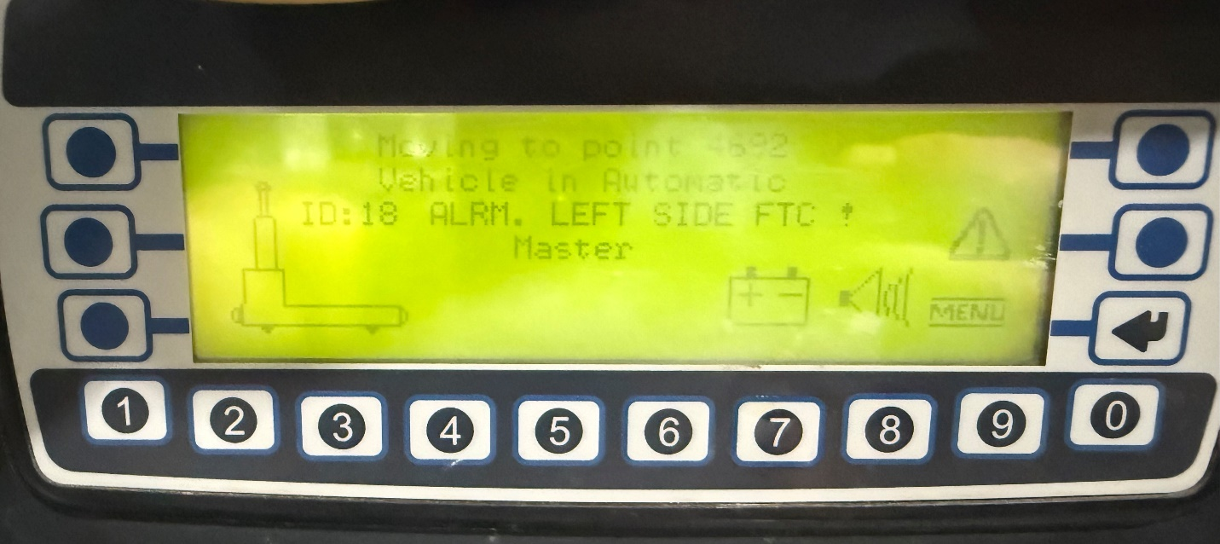
How To Fix:
Clear the obstruction from the AGV’s left arm sensor.
Perform the automatic sequence:
- Automatic Mode
- Press the Green button
- Press the Blue button

